**NAME OF SCHOOL: ................................................................................**

**NAME OF CANDIDATE: ..........................................................................**

**INDEX NO: ..................................... SIGNATURE: ................................**

**273/2**

**GEOGRAPHY**

**Paper 2**

**JULY/AUGUST**

**2 ½ hours**



**ELITE EXAMINATION BUREAU MOCK 2019**

**Uganda Certificate of Education**

GEOGRAPHY

**Paper 2**

2 hours 30 minutes

**INSTRUCTIONS TO CANDIDATES:**

* *Answer* ***four*** *questions only.*
* *Choose* ***two*** *questions from part* ***I*** *and* ***two*** *from part* ***II****.*
* *In part* ***II****, only* ***one*** *question should be chosen from any* ***one*** *region.*
* *Any additional question(s) answered will* ***not*** *be marked.*

**PART I: THE REST OF AFRICA**

Answer only **two** questions from this part.

1. a) Draw a sketch map of Africa and on it mark and name:

(i) highlands: Adamawa and Cape ranges,

ii) basins: Congo and Chad,

iii) **one** enclave territory,

iv) river Orange. (7 marks)

b) Describe the formation of the Cape Ranges. (5 marks)

c) Explain the problems facing land use in the highland areas of Africa.

(8 marks)

d) Outline the steps being taken to overcome the problems in (c) above.

(5 marks)

2. Study Figure **1:** Part of the Nile basin and answer the questions that follow.

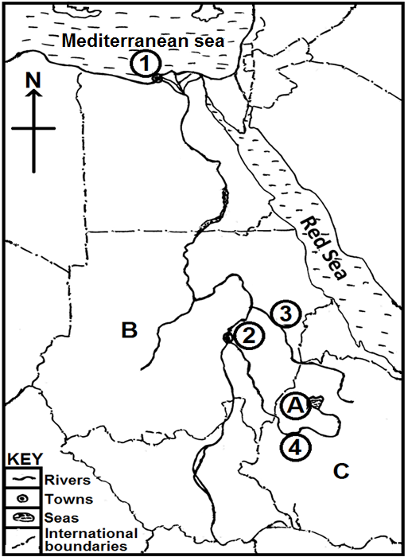

a) Name the:

i) towns marked **1** and **2**.

ii) rivers marked **3** and **4**.

iii) lake marked **A**.

iv) countries marked **B** and **C**. (7 marks)

b) Giving specific examples, describe the economic activities in any **one** Nile basin country named in a(iv) above. (8 marks)

c) Explain the problems facing the lower Nile basin region. (6 marks)

d) Outline the measures being taken to solve the problems in (c) above.

(4 marks)

3. Study the table **1** below, showing Slum Population Growth in selected African countries 1990 – 2000 and answer the questions that follow.

|  |  |
| --- | --- |
| Country | Slum Population Growth (percentage) |
| Democratic Republic of Congo  Burkina Faso  Egypt  Angola  Cote d’vôire | 117  34.6  19  159  105 |

Adapted: World Migration Report- Africa report. Pdf. Mariama Awumbila P.10

a) Draw a bar graph to represent the information contained in the table above. (7 marks)

b) Identify the country with the:

i) highest,

ii) lowest (2 marks)

slum population growth between 1990 – 2000.

c) Describe the conditions responsible for the highest slum population growth in the country identified in b (i) above. (6 marks)

d) i) Explain the challenges facing people living in Africa’s slums.

(6 marks)

ii) Outline the steps that are being adopted to solve the challenges in d(i) above. (4 marks)

4. a) Draw a sketch map of Gabon and on it mark and name:

i) exhausted and virgin forests,

ii) river Ogooue,

iii) towns: Port Gentil and Franceville,

iv) the Equator,

v) Neighbouring country: Congo. (8 marks)

b) Describe the factors that have favoured the development of forestry in Gabon. (6 marks)

c) Explain the contribution of the forestry sector to the development of Gabon. (6 marks)

d) Outline the effects of over exploitation of forests in the exhausted timberlands on the environment. (5 marks)

**PART II: STUDIES IN DEVELOPMENT**

Answer **two** questions from this part

**REGION I: NORTH AMERICA**

5. a) Draw a sketch map of the Great Lakes and St. Lawrence sea way and on it,mark and name:

i) lakes: Huron and Ontario,

ii) river St. Lawrence,

iii) ports: Chicago and Montreal,

iv) canals: Welland and Soo. (8 marks)

b) Describe the conditions which led to the construction of the Great Lakes and St. Lawrence sea way. (8 marks)

c) Explain the problems still limiting effective navigation along the Great Lakes and St. Lawrence sea way. (6 marks)

d) Outline the measures being taken to solve the problems in (c) above.

(3 marks)

6. Study Figure **2**: Map showing the location of the Canadian wheat growing provinces in Canada and answer the questions that follow.

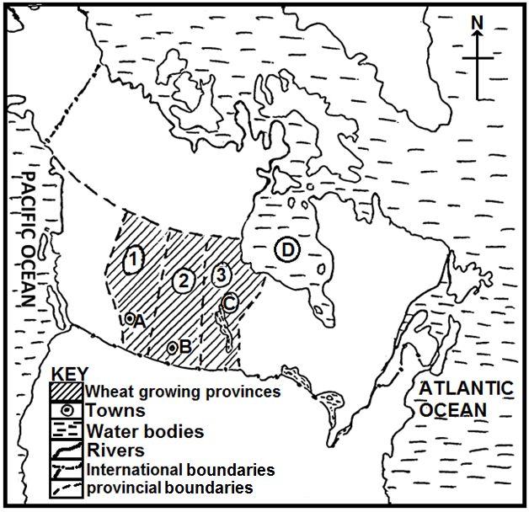

a) Name the:

i) wheat growing provinces marked **1**, **2** and **3**.

ii) towns marked **A** and **B**.

iii) Water body marked **C**.

iv) bay marked **D**. (7 marks)

b) Describe the conditions that influenced the location of large scale wheat farms in the Canadian prairies. (08 marks)

c) Explain the benefits of wheat growing to Canada. (6 marks)

d) Outline the problems facing wheat farmers in the Canadian prairies.

(4 marks)

7. a) Distinguish between “Log Low” and “Log High”. (4 marks)

b) Describe the factors which have favoured logging in British Columbia.

(6 marks)

c) Explain the importance of logging in British Columbia. (8 marks)

d) i) Mention the **three** categories of people involved in the logging activity in British Columbia. (3 marks)

ii) Outline the problems facing loggers in British Columbia. (4 marks)

**REGION II: RHINELANDS**

8. Study the Figure **3**: Map of Germany and answer the questions that follow.

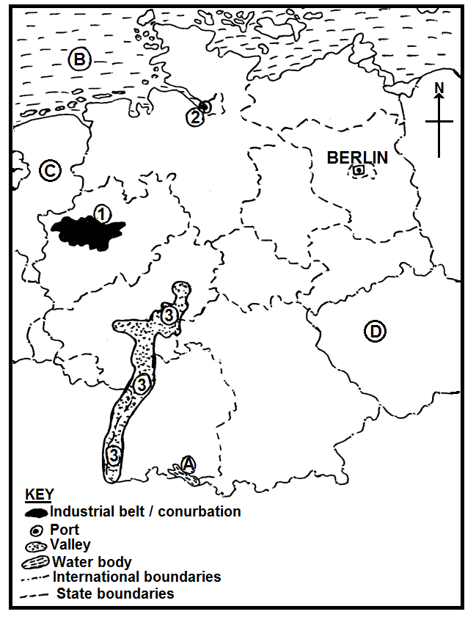

a) Name the:

i) industrial Conurbation marked **1**,

ii) port marked **2**,

iii) valley marked **3**,

iv) water bodies marked **A** and **B**,

v) neighbouring countries marked **C** and **D**. (7 marks)

b) Name any **two**

i) towns in the industrial conurbation marked 1. (2 marks)

ii) types of industries in any **one** town identified in b (i) above.

(2 marks)

c) With examples, describe the factors that have led to the development of industries in Germany. (8 marks)

d) Outline the

i) problems facing industries in Germany. (3 marks)

ii) steps being taken to solve the problems in d(i) above. (3 marks)

9. Study the table **2** below, showing Hydro Electric Power and Nuclear Electricity generation (in thousand Gwh) in Switzerland between 2010 – 2014 and answer the questions that follow.

|  |  |
| --- | --- |
| Year | Hydro Electric Power and Nuclear Electricity generation in thousand Gwh |
| 2010 | 62.7 |
| 2011 | 63.6 |
| 2012 | 64.3 |
| 2013 | 64.7 |
| 2014 | 66.2 |

Adapted:Energy statistics report Switzerland June 2016 P17 and 18.

a) Draw a line graph to represent the information in the table. (7 marks)

b) Calculate the percentage change in hydro electric power and nuclear electricity generation between 2010 and 2014. (2 marks)

c) Explain the effects of power generation on the environment in Switzerland. (8 marks)

d) Outline

i) the problems facing the power sector in Switzerland. (5 marks)

ii) steps being taken to solve the problems in d(ii) above. (3 marks)

10. a) Draw a sketch map of Luxembourg and on it, mark and name:

i) physical regions: Oesling and Gutland,

ii) rivers: Sure and Our,

iii) towns: Luxembourg and Wiltz,

iv) neighbouring country: France. (8 marks)

b) Describe the influence of physical factors on human activities in Luxembourg. (8 marks)

c) Explain the contribution of human activities to the development of Luxembourg. (6 marks)

d) Outline the effects of human activities on the physical environment in Luxembourg. (3 marks)

**REGION III: CHINA**

11. a) Draw a sketch map of the Sikiang River Valley and on it mark and name:

i) towns: Kweilin and Wuchow,

ii) rivers: Sikiang and Mekong,

iii) Hainan Island,

iv) the East China Sea. (7 marks)

b) Describe the measures undertaken by the Chinese government to improve the Sikiang River Basin. (6 marks)

c) Explain the contribution of the Sikiang River Basin to the development of China. (8 marks)

d) Outline the problems caused by the developments along the Sikiang River Basin on the environment. (4 marks)

12. Study the table **3** below, showing China’s imports by value in 2006 (in million US$) and answer the questions that follow.

|  |  |
| --- | --- |
| **Commodity** | **Total import value (in million US$)** |
| Ores and metals | 71,231 |
| Manufactures | 561,937.3 |
| Agricultural raw materials | 31,658.44 |
| Food | 23,743.83 |
| Fuels | 94,975.32 |
| Others | 7,914.61 |
| Total | 791,461 |

Adapted: 2008 World development indicators: The World Bank. P214.

a) Draw a pie chart to show the relative importance of each import commodity. (9 marks)

b) Identify the commodity with the:

i) highest (1 mark)

ii) lowest (1 mark)

import value in China in 2006.

c) Describe the factors that have favoured the importation of the commodity identified in b(i) above. (8 marks)

d) i) Name any **two** sea ports through which China’s import commodities and handled. (2 marks)

ii) Outline the challenges to china’s import trade. (4 marks)

13. Study Figure **4**: Map of part of Eastern China and answer the questions that follow.

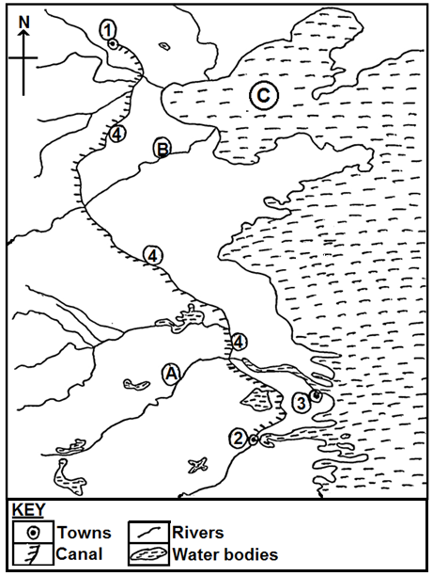

a) Name the:

i) towns marked **1**, **2** and **3**.

ii) canal marked **4**.

iii) rivers marked **A** and **B**.

iv) water body marked **C**. (7 marks)

b) Describe the conditions that have favoured the development of any **one** town named in a (i) above. (8 marks)

c) Explain the problems facing towns in Eastern China. (6 marks)

d) Outline the steps that should be taken to solve the problems in (c) above. (4 marks)

**END**